**Adding a new Cost Item**

The References page 'List of Cost Items' displays all the cost items defined by the GSI Cost Tool 'super user'.

If a new Cost Item is needed, there are 3 elements that need to be completed

1. Create Cost Item
2. Create Cost Item Default Equation and Factors
3. Create at least 1 Cost Item Default Cost

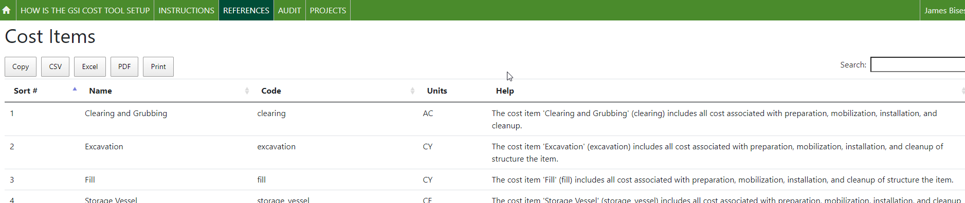

Note: *for each Cost Item the 'Code' and the 'Name' are unique.*

**Note:** *Once a Cost Item has been created, and used by users, it should not be deleted. It can be updated – by changing the Name and or Code, but this will change the values displayed in all the Scenarios that already exist.*

***Note****: Once a Cost Item has been created, additional configuration is required to define the default cost items associated with the structure. A Cost Item which has no default costs or Equations and Default Factors cannot be used by users.*

New values are entered using the 'GSI Cost Tool Admin Page', which is only available to users who have been granted 'superuser' status. When a superuser logs into the GSI Cost Tool, the menu in the upper right corner of the screen has 3 options. Use the first option to open the 'GSI Cost Tool Admin Page' (See Adding a new Areal Feature for images)

**Cost Item**

On the GSI Cost Tool Admin Page the administrator can add, edit, and delete data. The administrator can select any option by selecting the name of the option, or the 'Change' menu button.

To review, and create, new Cost Items, select the option from the Site administration list. The information displayed on the admin page is the same shown in the Reference page.

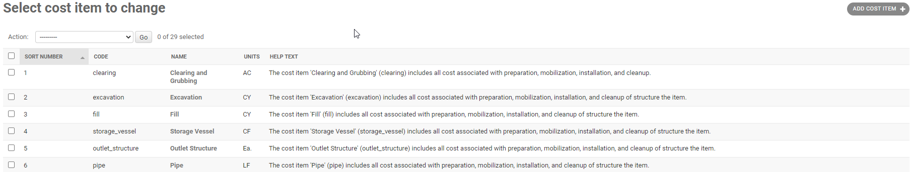

To create new value – use the button 'ADD COST ITEM in the upper right corner.

In the screen that opens, enter the information for the new Cost Item. Then hit the SAVE button on the lower right corner of the screen.

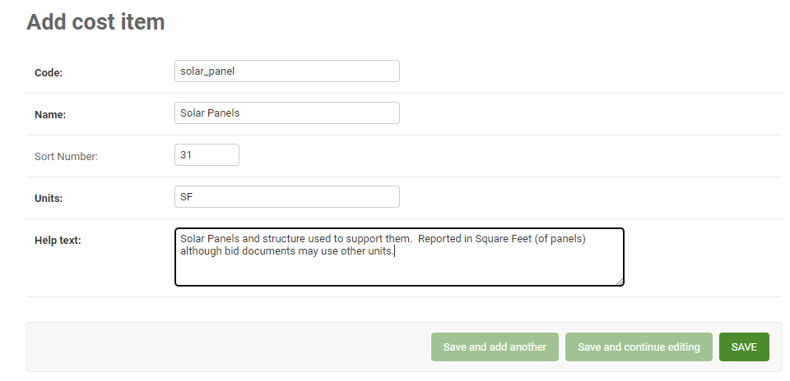

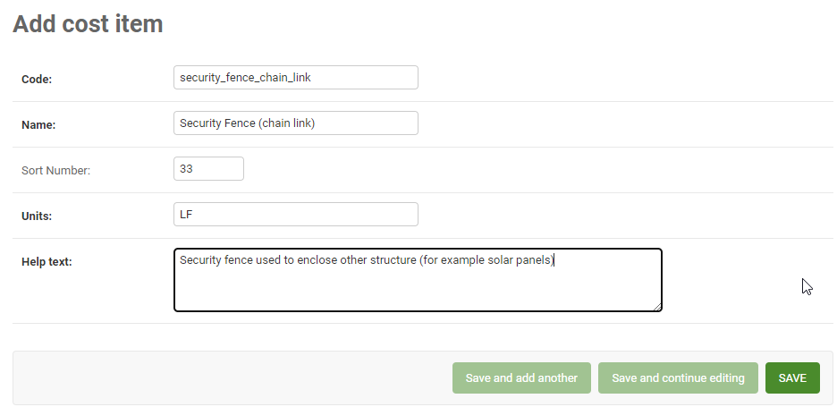

On the list of Cost Items, the new entry should be added to the list.

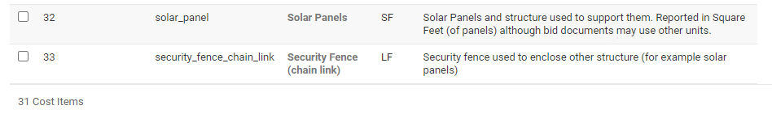

Once the Cost Item(s) have been added, they need to have 2 additional configurations – setting the 'Default Costs', and setting the 'Default Equations and Factors'

**Cost Item Default Equations and Factors**

The default equations and factors are set using the GSI Cost Tool Admin Page – selecting 'Cost Item Default Equations' – and then on that page using the 'ADD COST ITEM DEFAULT EQUATIONS' button. The following 2 examples are for adding default costs for the new cost items 'Solar Panels', and 'Security Fence (chain link).

1. Equation – look at other cost items and decide what factors are required to calculate the cost
2. Replacement life – how often (if ever) does the cost item need to be replaced, in years
3. Operating and Maintenance Percent – what is the annual cost of operating and maintaining the cost item, in percent of the unit cost.

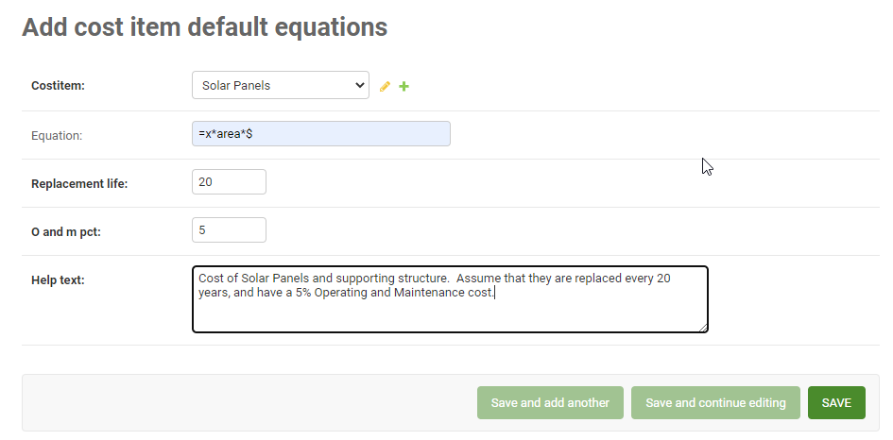

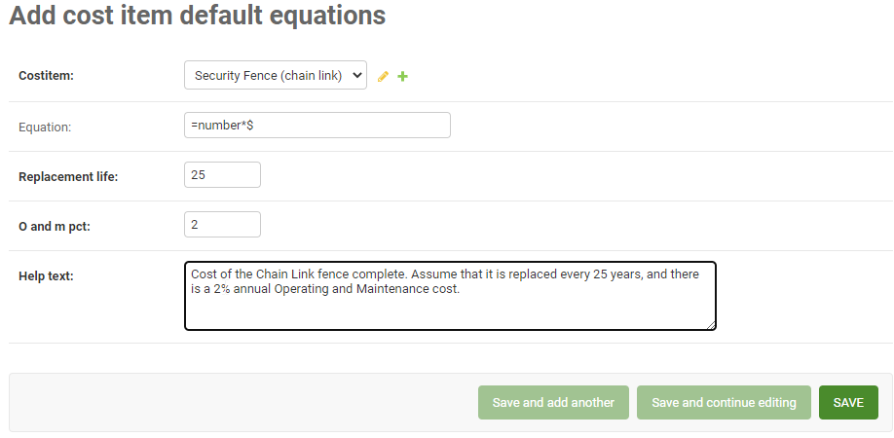

**Cost Item Default Costs**

The default costs are set using the GSI Cost Tool Admin Page – selecting 'Cost Item Default Costs' – and then on that page using the 'ADD COST ITEM DEFAUL COSTS' button. A complete explanation of adding these is in the document Adding a new Cost Item Default Cost. The following 2 examples are for adding default costs for the new cost items 'Solar Panels', and 'Security Fence (chain link).

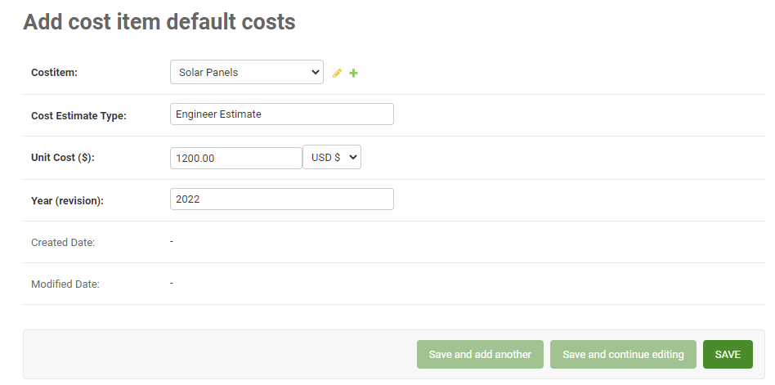

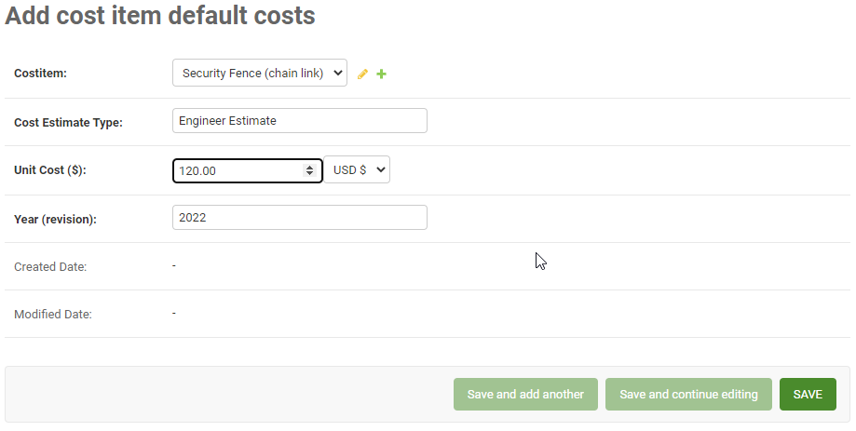

Now the 2 new Cost Items are completely set up and could be selected and used by users.

**(optional) Structure / Cost Item Default Factors**

If the new Cost Item is regularly used with an existing structure, it should be assigned by creating a new Structure / Cost Item Default Factor. The two cost items created in this document for example can be added as default items to the (new) structure 'Solar Garden'.

To create a new 'Structure Cost Item Default Factors', select the ' Structure Cost Item Default Factors' option from the Site administration list. Then click the 'ADD STRUCTURE COST ITEM DEFAULT FACTORS' button and enter the information.

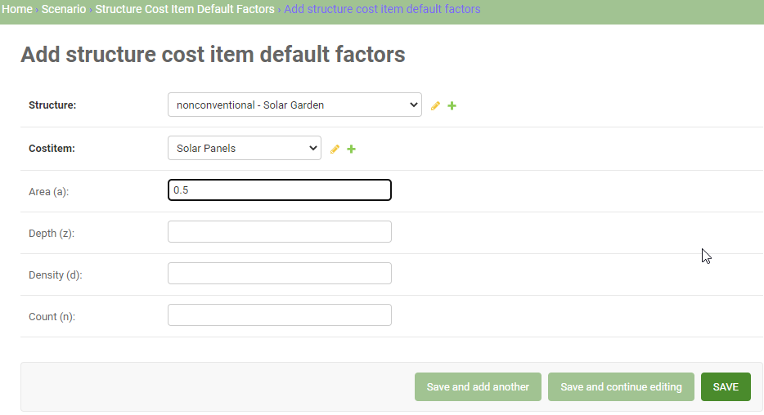

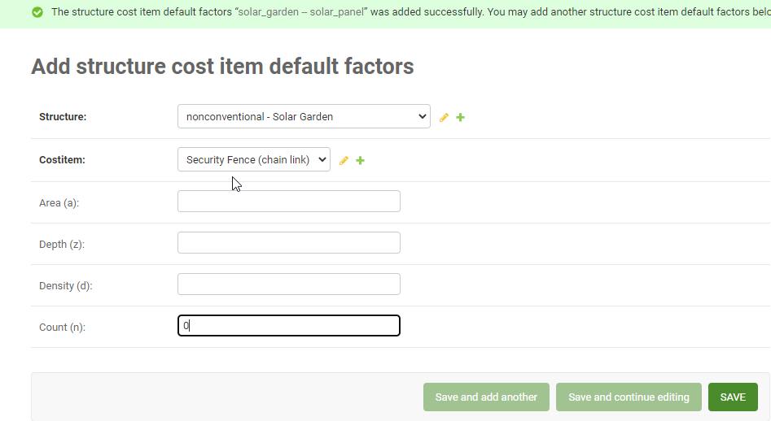

Returning to the list and selecting to filter by Structure Name 'Solar Garden' will show the new default cost items.

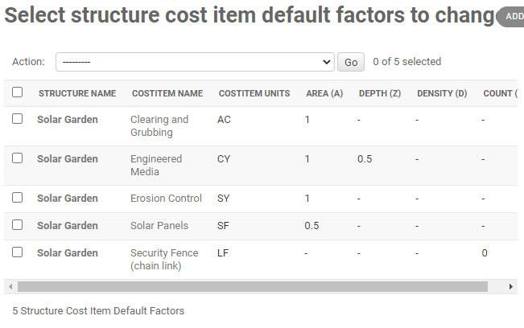

**Review in GSI Cost Tool**

Now that the new Cost Items are configured – and added as defaults to a Structure, they can be used by users in the GSI Cost Tool. Users will find the new Cost Items on the Cost Item Unit Cost page

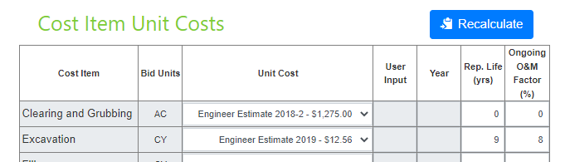

…

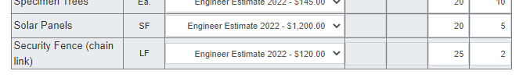

If the Structure is used in the Scenario, the user will see the new Cost Items on the Structure/Cost Item User Factors tab.

Now that the new Structure is configured – it can be used by users in the GSI Cost Tool. Check the box, and then enter an area for the Solar Garden.

